1) Is your browser running HTTP version 1.0 or 1.1? What version of HTTP is the server running?

- Both browser and server are running 1.1  
(The following screenshots were provided by Khan)

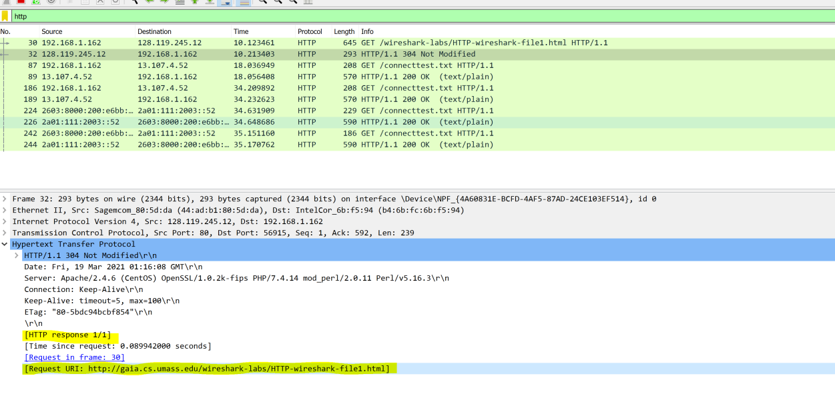

2) What languages (if any) does your browser indicate that it can accpet to the server?

- Accept-Language: en-US,en;q=0.9

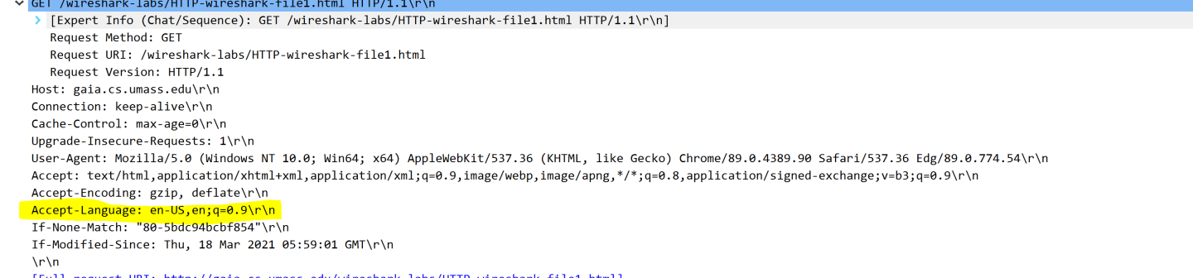

3) What is the IP address of your computer? Or if the gaia.cs.umass.edu server?

- 128.119.245.12 is my IP address (this will be different for my groupmates and the following screenshot)

- 192.168.1.74 is the gaia.cs.umass.edu servers IP address

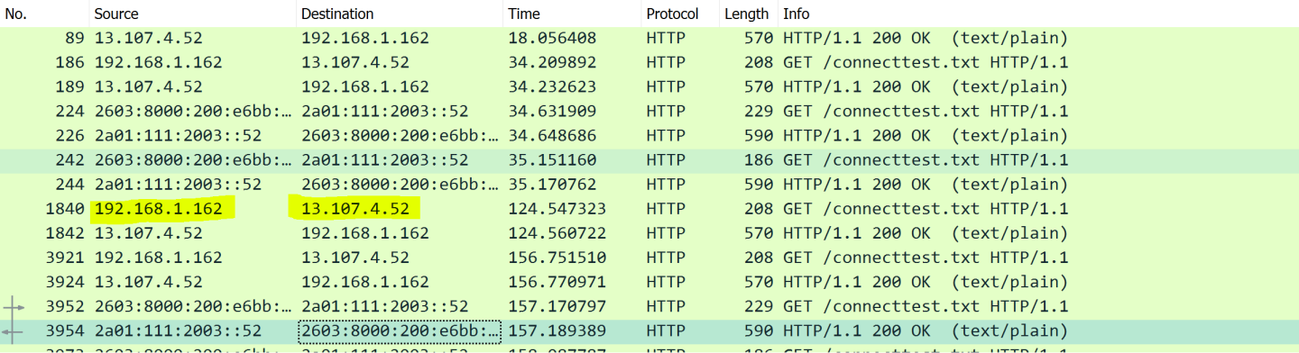

4) What is that status code returned from the server to your browser?

- 200 - OK

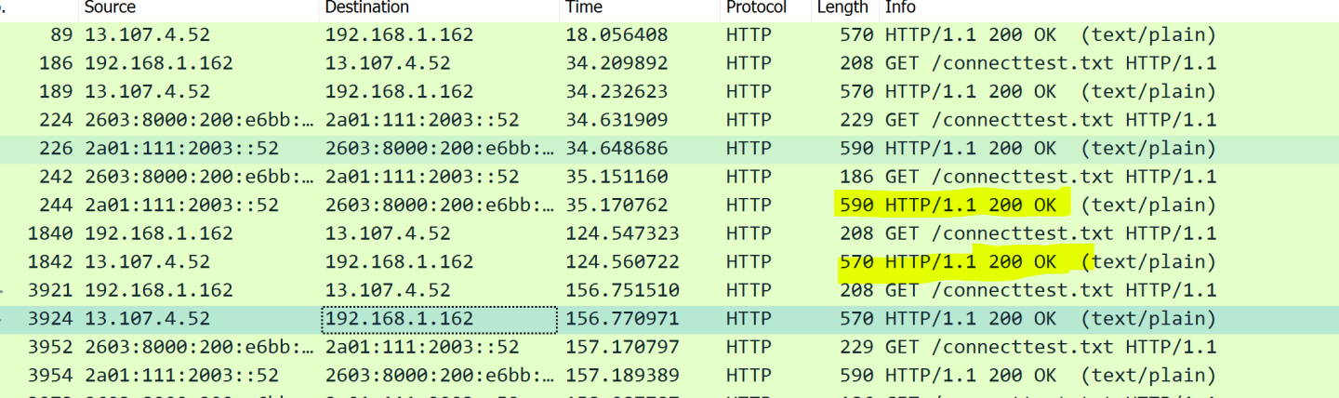

5) When was the HTML file that you are retrieving last modified at the server?

- Mon, 06 Feb 2017 6:59:01GMT\r\n

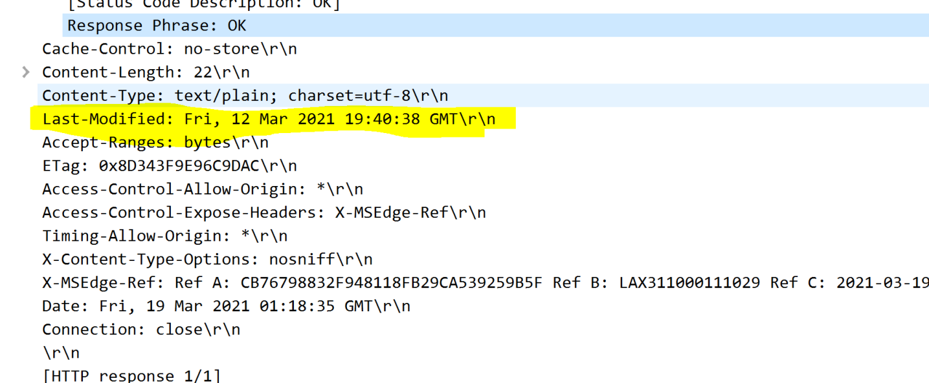

6) How many bytes of content are being returned to your browser?

- Content length: 371\r\n

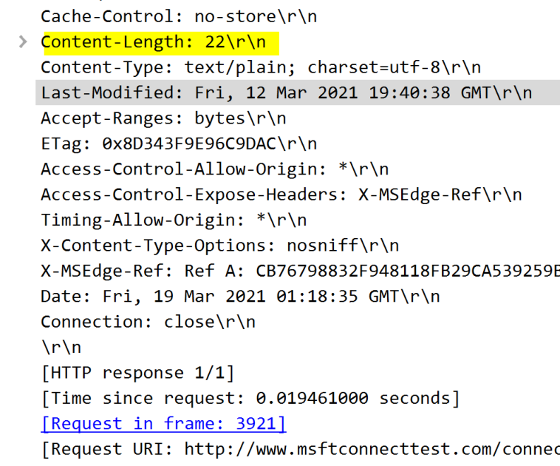

7) By inspecting the raw data in the packet content window, do you see any headers within the data that are not displayed in the

packet-listing window? If so, name one

- No, I do not see any headers that are not displayed in the packet window

8) Inspect the contents of the first HTTP GET request from your browser to the server. Do you see an "IF-MODIFIED-SINCE" line in the HTTP get?

- No, there is no “IF-MODIFIED-SINCE” line in the HTTP GET

9) Inspect the contents of the server response. Did the server explicitly return the contents of the file? How can you tell?

- Yes, one of the lines says "Line-based text data: text/html (10 lines)"

- Opening this section reveals the contents of the file

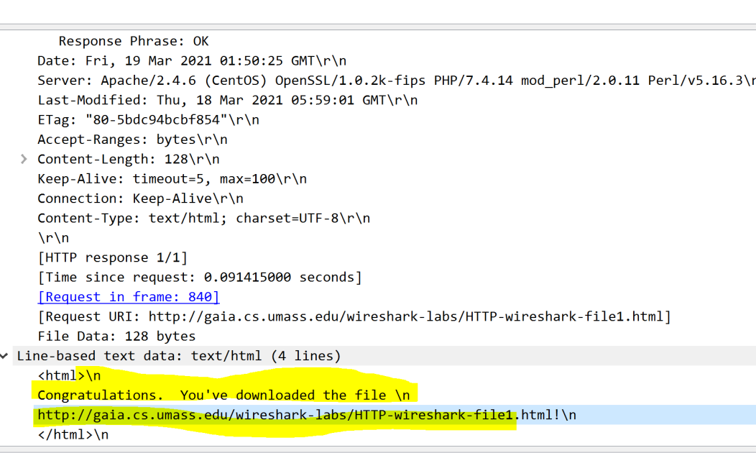

10) Now inspect the contents of the second HTTP GET request from your browser to the server. Do you see an "IF-MODIFIED-SINCE:" line

in the HTTP GET? If so, what information follows the "IF-MODIFIED-SINCE:" header?

- It is there, followed by the last time i visited the site

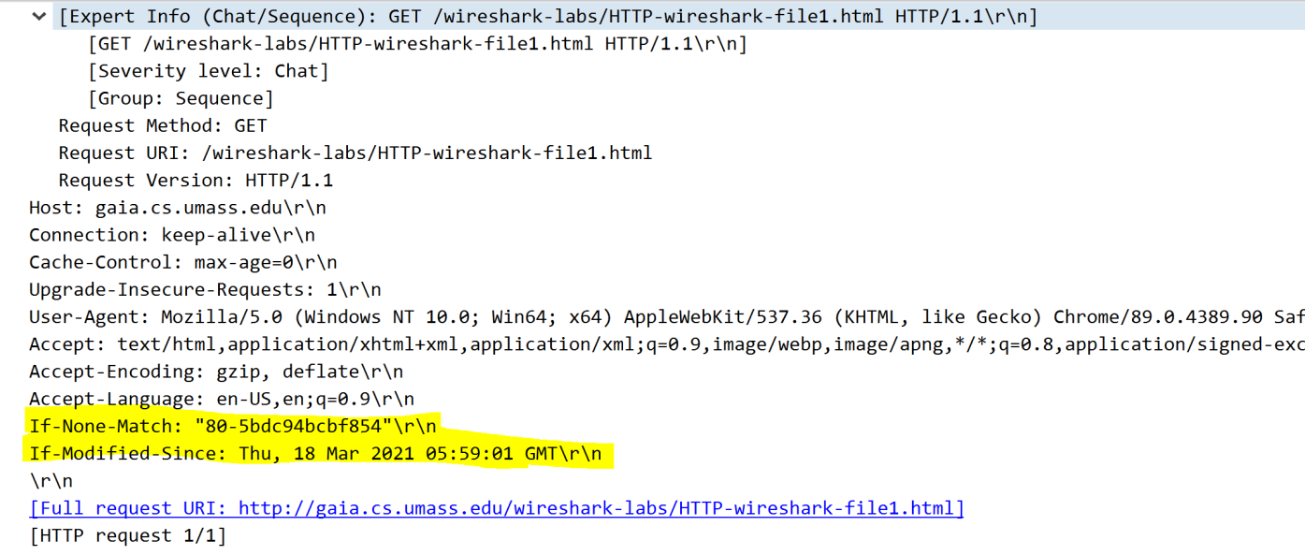

11) What is the HTTP satus code and phrase returned from the server in response to this second HTTP GET? Did the server explicitly return

the content of the file? Explain.

- Code 304 Not Modified. It did not explicitly return the contents of the file, because the file we have cached is up to date.



12) How many HTTP GET request messages did your browser send? Which packet number in the trace contains the GET message for the bill or rigths?

- Only one get request. Packet number 4895

13) Which packet number in the trace contains the status code and phrase associated with the response to the HTTP GET request?

- Packet number 4912

14) What is the status code and phrase in the response?

- Status Code 200 OK

15) How many data-containing TCP segments were needed to carry the single HTTP response and the text of the Bill of Rights?

- 4 Reassembled TCP segments

16) How many HTTP GET request messages did your browser send? To which Internet addresses were these GET requests sent?

17) Can you tell whether your browser downloaded the two images serially, or whether they were downloaded from the two web sites in parallel? Explain.

18) What is the server’s response (status code and phrase) in response to the initial HTTP GET message from your browser?

19) When your browser sends the HTTP GET message for the second time, what new field included in the HTTP GET message?